Banking Card Analytics Project — Platform Comparison
Objective 1 — Customer Segmentation (Value & Risk)
Segment the current customer base into High-Value, Medium-Value, and At-Risk tiers using credit score, income
Objective 2 — Transaction & Spending Trends
Track how customers are spending across time and category
Objective 3 — Credit Utilization & High-Risk Accounts
Monitor credit utilization to flag over-leveraged, high-risk customers.
Objective 4 — Fraud Monitoring
Monitor fraudulent activity to surface high-risk transactions, categories, and locations — framed as near-real-time fraud surveillance.
Data source
https://www.kaggle.com/datasets/computingvictor/transactions-fraud-datasets?select=transactions_data.csv
Dataset: 5 files (3 CSV, 2 JSON), largest is transactions_data.csv at 1.17 GB and train_fraud_labels.json at 151 MB (~13M records).
Azure Synapse Analytics

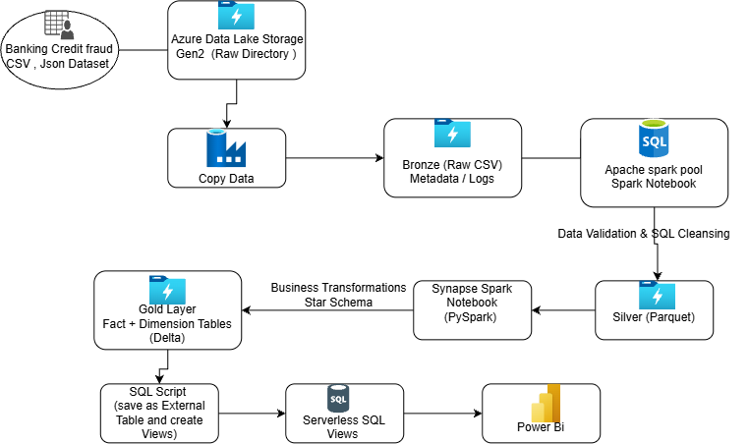

Microsoift Fabric
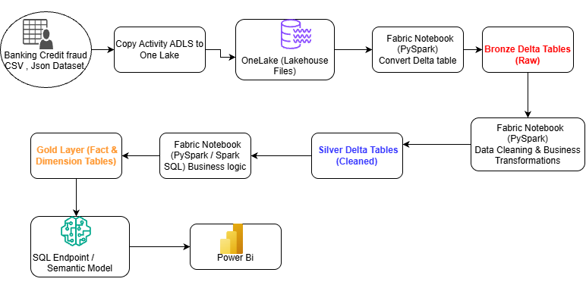

Data Bricks
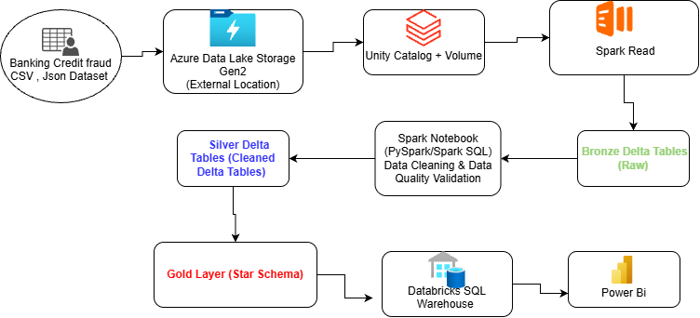

ADLS Account
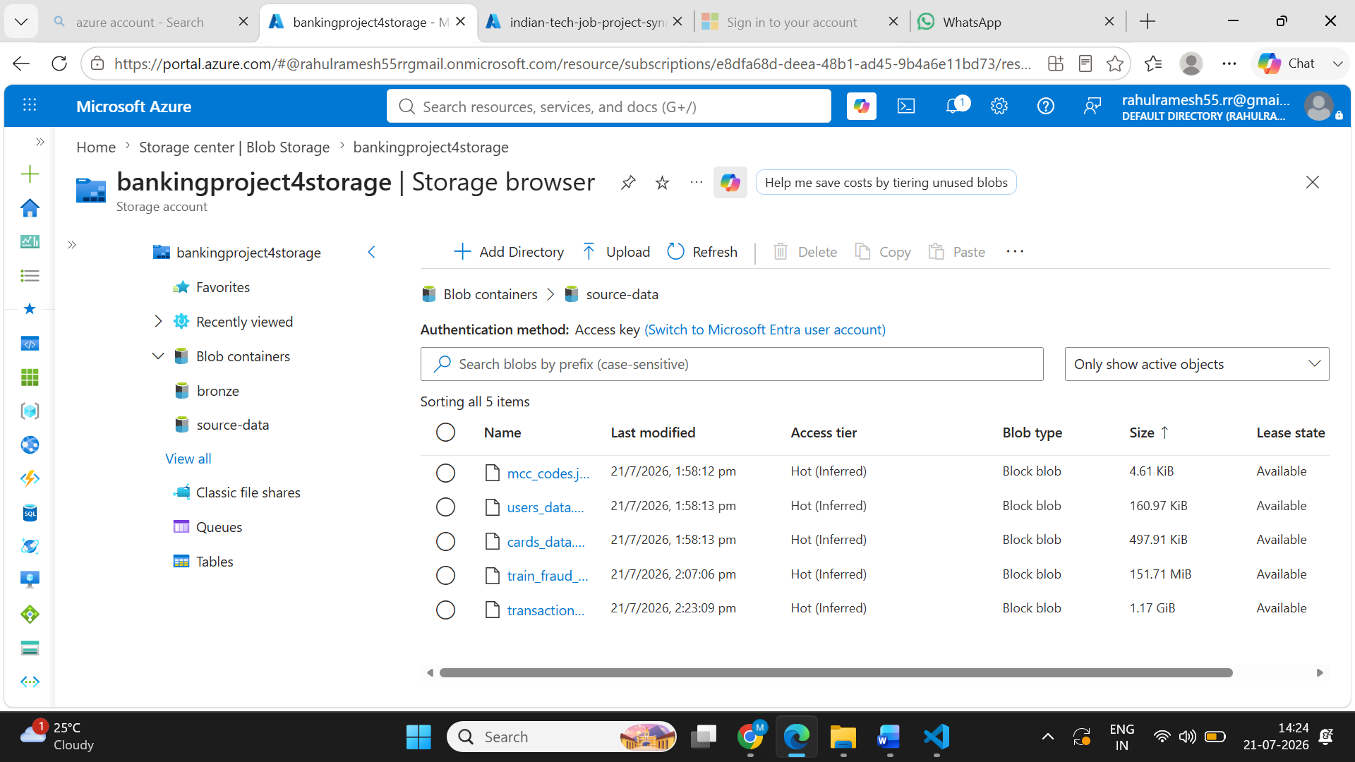
Pipe line Execution
Synapse
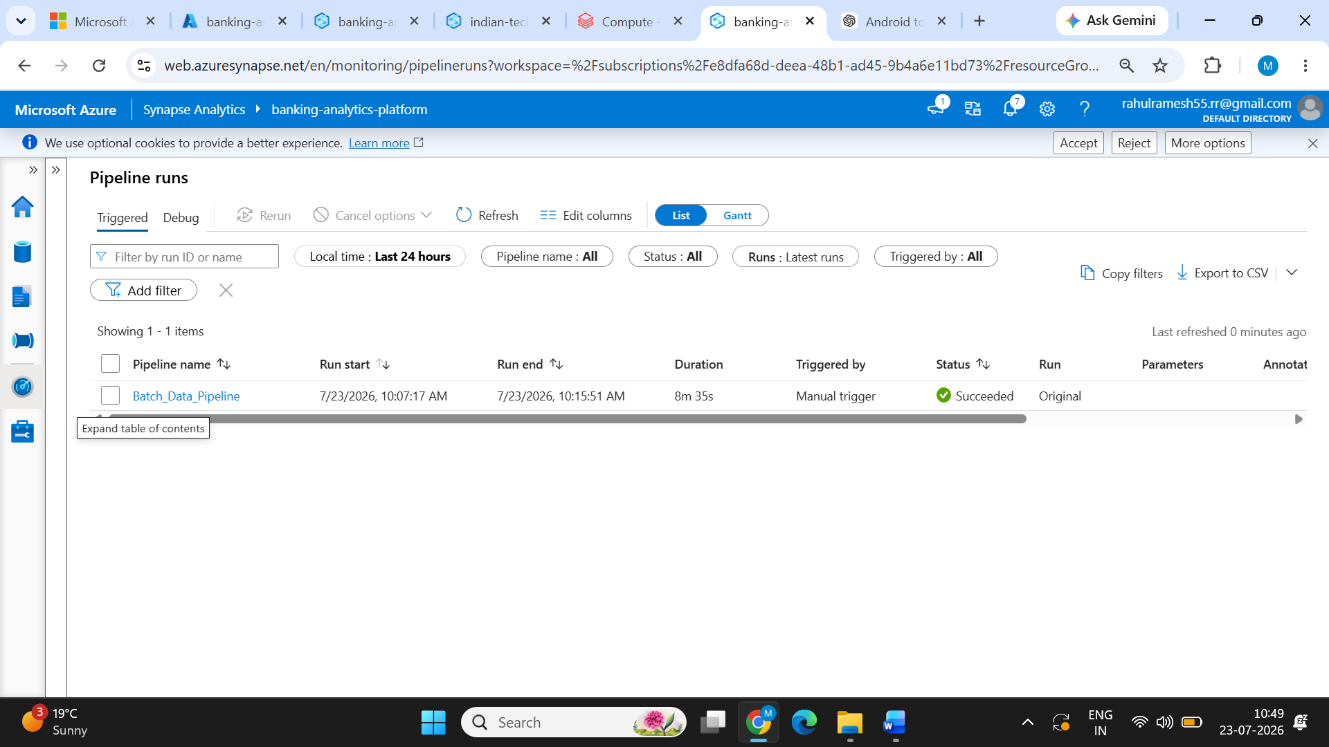

Data Bricks
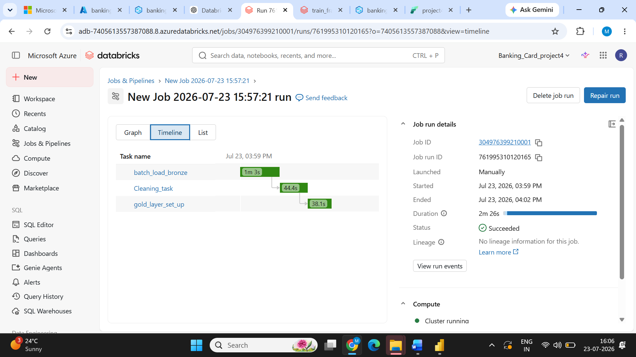

Fabric
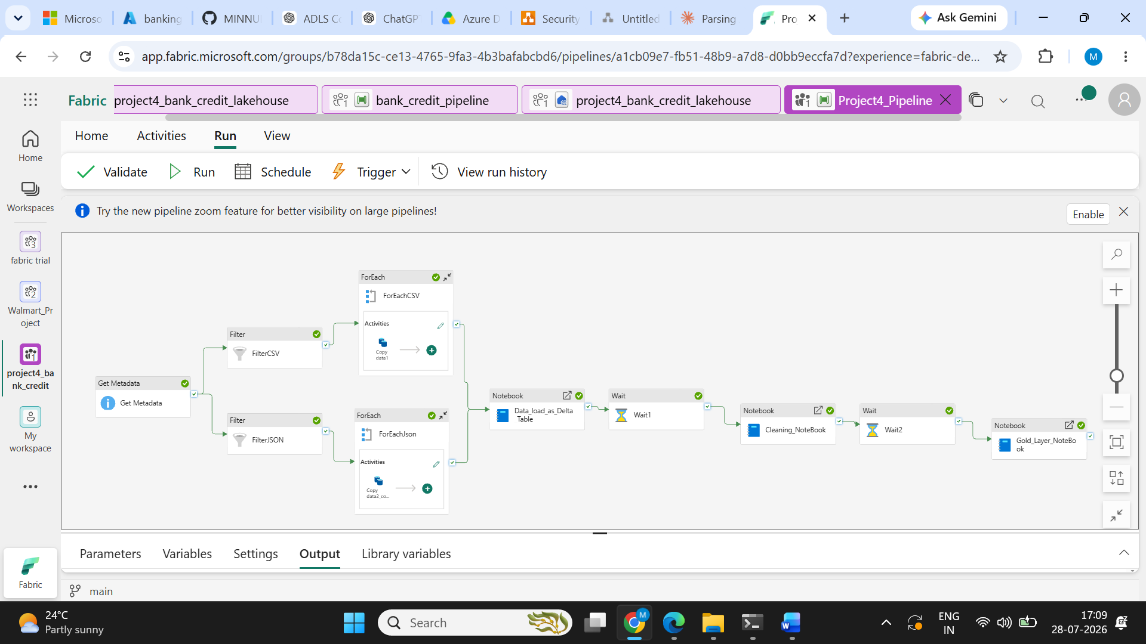

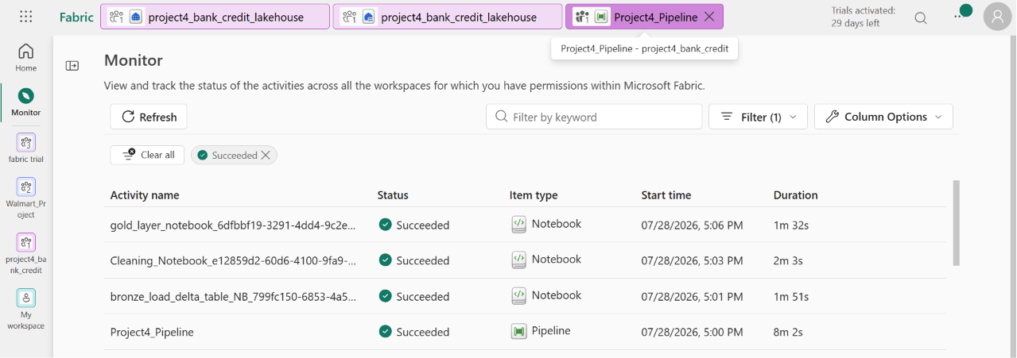

Patform Comparison — Azure Synapse vs Azure Databricks vs Microsoft Fabric

Factor | Azure Synapse Analytics | Azure Databricks | Microsoft Fabric
Data Ingestion | Used Copy Activity to move files from ADLS. Supports multiple connectors and file formats. Notebook-based PySpark processing can also be used for transformations. | Used ADLS storage with Unity Catalog External Locations. Databricks provided flexible options such as Auto Loader and COPY INTO. File-based ingestion and PySpark processing were straightforward. | Used Copy Activity to load files from ADLS into the Lakehouse. A practical limitation observed was that the Copy Activity requires a file format to be selected, so CSV and JSON files could not be handled generically in one copy activity. Separate copy activities/branches were required for different file formats, increasing pipeline complexity.
Time to Build Solution | Moderate to Slow — Additional activities and configuration were required for SQL scripts, notebooks, Spark pools, and pipeline components. | Fastest — Notebook-based development allowed ingestion and Bronze/Silver/Gold transformations to be developed efficiently. Unity Catalog External Locations were reusable. | Fast — Unified Lakehouse, Pipeline, Notebook, and Power BI environment reduced setup effort. However, separate Copy Activities for CSV and JSON and additional Wait activities increased pipeline design complexity.
Full Pipeline Execution | Approximately 8 min 35 sec in the earlier test. Spark pool startup contributed to the overall execution time. | Approximately 2 min 26 sec after cluster initialization. The actual data processing was the fastest among the three. Cluster startup was approximately 10 minutes. | Approximately 8 min 2 sec after adding Wait activities to manage capacity availability. The pipeline successfully completed, but capacity constraints affected the execution design and required additional waiting steps.
Capacity / Compute Impact | Spark pool startup created significant overhead before notebook execution. | Cluster startup was the largest initial overhead, but once running, processing was fast and stable. | Capacity limitations were encountered during development. Wait activities were introduced between processing stages to avoid capacity-related failures and allow resources to become available.
Orchestration | Strong — Native Synapse Pipelines with rich activities, scheduling, triggers, dependencies, and monitoring. | Powerful but more engineering-oriented — Databricks Workflows are effective for notebook/job orchestration but can require additional configuration for complex workflows. | Easy and visual — Fabric Data Factory Pipelines provide a drag-and-drop experience.
Git Integration | Available, but setup and authentication can require additional configuration. | Notebook version control was effective, but manually created Volumes and External Locations created outside the notebook workflow need separate handling and are not automatically captured as notebook code. | Git integration worked well after configuring the required Personal Access Token. Most workspace development artifacts can be managed through the Git workflow.
Power BI Integration | Strong integration through Synapse SQL/serverless SQL endpoints. Suitable for reporting over curated analytical data. | Good integration through SQL Warehouse and Delta-based data. Connecting Power BI directly to interactive clusters can be less practical because of cluster availability and cost considerations. | Strongest integrated experience. Lakehouse, SQL endpoint, and Power BI work together within the same platform. Direct Lake provides an efficient architecture for Power BI reporting.
Ease of Development | Moderate — Comfortable for SQL-focused development, but requires managing Spark pools, pipelines, linked services, and SQL components. | Easy for data engineers — Stable notebook experience and reusable Unity Catalog storage configuration simplified development. | Easy to start — Integrated workspace reduced initial setup. However, capacity issues and the need for Wait activities affected the practical development experience.
Code Assistance | Copilot capabilities are available in the Microsoft ecosystem, but access was limited in the project environment. | Strong — Databricks Assistant provided useful assistance with PySpark/SQL development and troubleshooting issues such as path and variable errors. | Good — Copilot can assist with Fabric notebooks, SQL, Dataflows, and Power BI, depending on licensing and availability.
Overall Project Observation | Reliable and suitable for enterprise Azure and SQL-heavy workloads, but higher setup and Spark startup overhead affected total execution time. | Best overall performance in this project. Fastest processing, stable development experience, flexible ingestion, and strong notebook/Git workflow. | Best integrated development experience with successful full pipeline execution at 8 min 2 sec, but capacity limitations affected execution and required Wait activities. File-format restrictions in Copy Activity also increased ingestion pipeline complexity.

